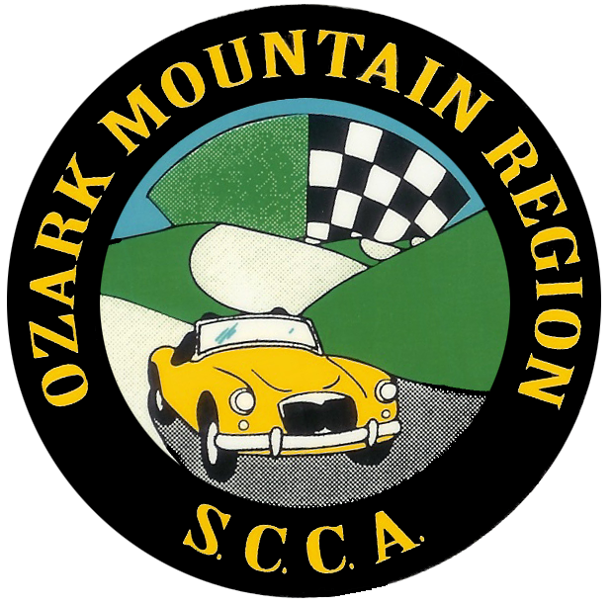 2025 OMR Supplemental Solo Regulations

Following rule 1.3.2.B of the SCCA rulebook, every person entering an OMR Solo event as a driver must have a valid driver’s license or valid driver’s permit under the supervision of their guardian/parent or assigned SCCA official. In addition, they must be prepared to show it at any time during the event. OMR events are meant to be fun and safe. Actions deemed unsafe by the Solo Safety Steward and Event Chairman will not be allowed, and the person who has committed the unsafe act, depending on the severity of the action, will at a minimum be warned to not continue with such behavior and at a maximum be disqualified for all future OMR Region events (pending BOD approval). Some examples of behavior that is not allowed: speeding through the grid, having any portion of your body outside of the car, moving your car while a cart is on the course, or “donuts”/burnouts whether on course, the grid, or even entering or leaving the event.
No more than two drivers may drive the same vehicle unless approved by the Event Chairman. A driver may not enter more than one vehicle. All drivers are responsible for fulfilling their work assignments as determined by the Event Chairman or his/her appointee. Failure to work may result in disqualification and/or loss of points and/or disqualification from future events.

Ozark Mountain Region follows rule 3.5 of the SCCA rulebook with regards to noise.

Entry fees are determined and published (web, entry, etc.) by the BOD. Those who cannot show positive proof of SCCA Membership as well as Non-members will pay non-member rate and will be required to complete a Weekend Membership form.

Drivers may receive an award for placement at any of the individual OMR Region points event based on the following criteria per SCCA rulebook Awards section

“One award for one to three entrants in a class; two awards for four
to six entrants in a class; three awards for seven to nine entrants in
a class; one additional award for every four additional entrants or
fraction thereof (e.g., six awards for 18 entrants).”

In the event of a 2 day MiDiv event hosted by OMR, it will count as two separate OMR Region points events.

OMR Region follows rule 1.3.2.D of the SCCA rules regarding passengers – you may need to provide your own if you need a junior helmet.

Class Championship Points will be awarded to each OMR SCCA member for placing within an OMR Points event. The best 2(two)* scores received during the season will be used to determine Class Champion. Any person must have competed in 2(two) OMR Region Points events and the driver must be a full member of OMR SCCA to be eligible, but non OMR members can keep members from earning higher position points (example: If a non-member wins an event, then 1st place points are not awarded to a member for that event). In the case of a tie at the end of the season, the award will be given to the driver with the most 1st places. If there is still a tie it will go to the driver with the most 2nd places and so on.
1st place 15 points 6th place 5 points
2nd place 12 points 7th place 4 points
3rd place 10 points 8th place 3 points
4th place 8 points 9th place 2 points
5th place 6 points 10th place 1 point
Autocrosser of the Year will be awarded to the driver who collected the most points from any and all classes that driver competed in that year. The best 2(two)* PAX scores received during the season will be used to determine AOTY Champion. Autocrosser of the Year must be a full member of OMR SCCA to be eligible. The points will be awarded based on PAX score. PAX multipliers will be adopted from the Chicago Region SCCA. In the case of a tie it will be given to the driver with the most 1st places. If there is still a tie it will go to the driver with the most 2nd places and so on. Non OMR members can keep members from earning higher position points (example: If a non-member wins an event, then 1st place points are not awarded to a member for that event).
1st place 15 points 6th place 5 points
2nd place 12 points 7th place 4 points
3rd place 10 points 8th place 3 points
4th place 8 points 9th place 2 points
5th place 6 points 10th place 1 point

Selection of Rookie of the Year will be by decision of the Board of Directors. Criteria may include participation, support and contribution to the club as a whole, and regular season event results. Rookie of the Year may be awarded to a driver who competed in no more than three previous SCCA regular season Solo events. The driver must be a full member of OMR SCCA before the last regular season event to be eligible.

*If for some reason there is an abbreviated season, the OMR SCCA will review and approve an altered event participation requirement for Class Championship points and Autocrosser of the Year award.

These supplemental rules may be modified at any time during the year as required to meet new circumstances. BOD approval is required to change the region's supplemental rules, and the BOD determines the effective date of the changes.

